Linear Regression

Dhruv Aggarwal

12/13/2020

# Simple Linear Regression (SLR)  
  
# Using fathers' heights to predict sons' heights using SLR.  
# Fathers height as predictor(Indep - X) and   
# Son's height as the response /Target(Dep - Y)  
require(UsingR)

## Loading required package: UsingR

## Loading required package: MASS

## Loading required package: HistData

## Loading required package: Hmisc

## Loading required package: lattice

## Loading required package: survival

## Loading required package: Formula

## Loading required package: ggplot2

##   
## Attaching package: 'Hmisc'

## The following objects are masked from 'package:base':  
##   
## format.pval, units

##   
## Attaching package: 'UsingR'

## The following object is masked from 'package:survival':  
##   
## cancer

require(ggplot2)  
head(father.son) # Dataset: father.son.

## fheight sheight  
## 1 65.04851 59.77827  
## 2 63.25094 63.21404  
## 3 64.95532 63.34242  
## 4 65.75250 62.79238  
## 5 61.13723 64.28113  
## 6 63.02254 64.24221

ggplot(father.son, aes(x=fheight, y=sheight))+geom_point()+  
 geom_smooth(method="lm")+labs(x="Fathers", y="Sons")

## `geom_smooth()` using formula 'y ~ x'

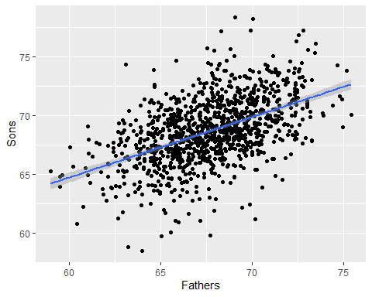

heightsLM = lm(sheight ~ fheight, data = father.son)  
heightsLM

##   
## Call:  
## lm(formula = sheight ~ fheight, data = father.son)  
##   
## Coefficients:  
## (Intercept) fheight   
## 33.8866 0.5141

summary(heightsLM)

##   
## Call:  
## lm(formula = sheight ~ fheight, data = father.son)  
##   
## Residuals:  
## Min 1Q Median 3Q Max   
## -8.8772 -1.5144 -0.0079 1.6285 8.9685   
##   
## Coefficients:  
## Estimate Std. Error t value Pr(>|t|)   
## (Intercept) 33.88660 1.83235 18.49 <2e-16 ***  
## fheight 0.51409 0.02705 19.01 <2e-16 ***  
## ---  
## Signif. codes: 0 '***' 0.001 '**' 0.01 '*' 0.05 '.' 0.1 ' ' 1  
##   
## Residual standard error: 2.437 on 1076 degrees of freedom  
## Multiple R-squared: 0.2513, Adjusted R-squared: 0.2506   
## F-statistic: 361.2 on 1 and 1076 DF, p-value: < 2.2e-16